

RECORD NOTEBOOK

BCS18ET3 – PHP / MYSQL LAB

DEPARTMENT

OF

COMPUTER SCIENCE AND ENGINEERING

**NAME :**

**REGISTER NO :**

**COURSE :** B. TECH CSE

**YEAR/SEM/SEC :** III/VI/F

2023-2024 (EVEN SEMESTER)



BONAFIDE CERTIFICATE

**REGISTER NO:**

**NAME OF LAB:** PHP / MYSQL LAB - (BCS18ET3)

**DEPARTMENT:** COMPUTER SCIENCE AND ENGINEERING

Certified that, this Record note book is a bonafide record of work done by

**XXXX** of **III Year B. Tech / CSE, Sec- ‘F’** in the **PHP / MYSQL LAB (BCS18ET3)** during the year **2023-2024**.

Signature of Lab-in-Charge Signature of Head of Dept

Submitted for the Practical Examination held on **---------------------------------**

Internal Examiner External Examiner

**INDEX**

|  |  |  |  |  |
| --- | --- | --- | --- | --- |
| **Exp.No** | **Date** | **Name of the Experiment** | **Page No.** | **Staff Signature** |
| 1. | 08/01/2024 | Determine whether a number is ‘odd’ or ‘even’ | 1 |  |
| 2. | 22/01/2024 | Switch-Case Statement | 3 |  |
| 3. | 29/01/2024 | Fibonacci Series Generation | 5 |  |
| 4. | 29/01/2024 | Determine Factorial of a number | 7 |  |
| 5. | 05/02/2024 | Class and object | 9 |  |
| 6. | 12/02/2024 | Inheritance | 11 |  |
| 7. | 19/02/2024 | Constructor And Destructor | 13 |  |
| 8. | 02/03/2024 | Rows*Columns multiplication table generation using nested for loops | 17 |  |
| 9. | 02/03/2024 | Display sorted array values | 20 |  |
| 10. | 04/03/2024 | Student Registration Form | 22 |  |
| 11. | 11/03/2024 | Inserting record into a database table using PHP/MySQL | 25 |  |
| 12. | 18/03/2024 | Tracking the number of visits made to a page | 29 |  |

|  |  |
| --- | --- |
| **Ex.No : 1** | **DETERMINE WHETHER A NUMBER IS ‘ODD’ OR ‘EVEN’** |
| **Date: 08/01/2024** |

# AIM:

To write a ‘PHP’ program to determine whether a given number is ‘odd’ or ‘even’.

# ALGORITHM:

1. Start
2. Read the number from the user.
3. Divide the number by 2.
4. If the remainder is equal to 0, print the number is ‘even’, else print it is ‘odd’.
5. Stop.

# PROGRAM:

# <html>

# <body>

# <?php

# $number=9873;

# if($number%2==0)

# {

# echo "$number is even number";

# }

# else

# {

# echo" $number is odd number";

# }

# ?>

# </body>

# </html>

# OUTPUT:

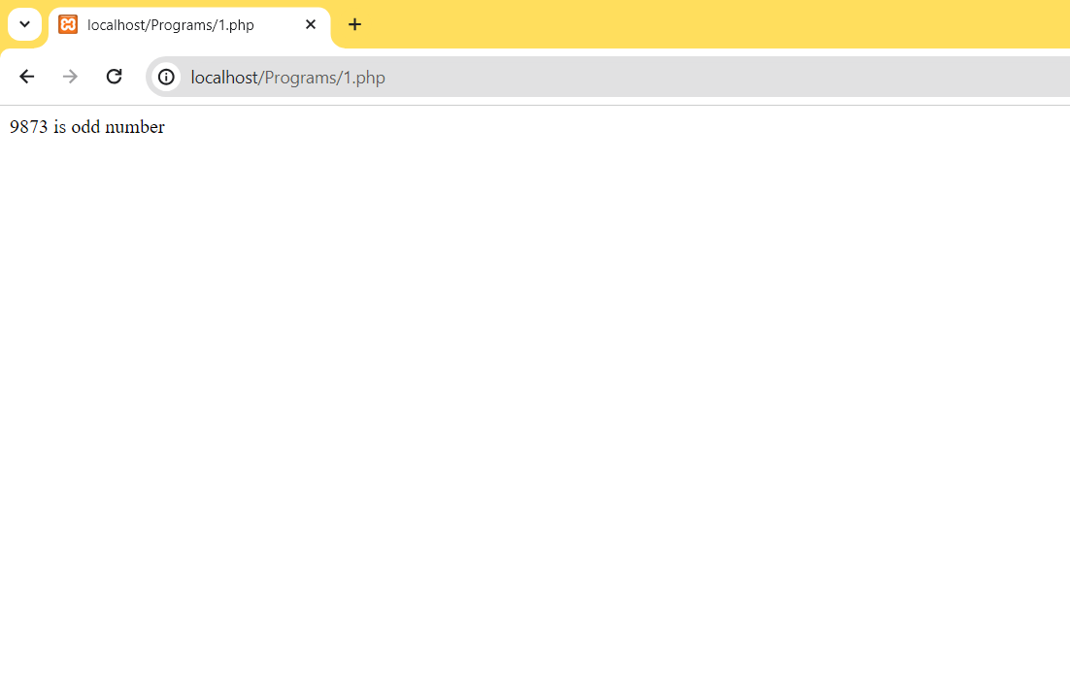

**RESULT:**

Hence, the ‘PHP’ program to determine whether a given number is ‘odd’ or ‘even’ is executed and the output verified.

|  |  |
| --- | --- |
| **Ex.No : 2** | **SWITCH-CASE STATEMENT** |
| **Date: 22/01/2024** |

# AIM:

To write a ‘PHP’ program to implement the switch-case statement.

# ALGORITHM:

1. Start
2. Read the favorite food from the user and assign it to a variable.
3. Compare the value of the variable against the different cases within the switch.
4. Print the message of the case against which the variable is matched.
5. Stop.

# PROGRAM:

<?php

$favfood = "rice";

switch ($favfood)

{

case "Chocolate":

echo "Your favorite food is Chocolate!";

break;

case "Curd":

echo "Your favorite food is Curd!";

break;

case "Tamarind":

echo "Your favorite food is Tamarind!";

break;

case "Briyani":

echo "Your favorite food is Briyani!";

break;

default:

echo "Your favorite food is neither rice, Chocolate, tomato,nor rasam!";

}

?>

# OUTPUT:

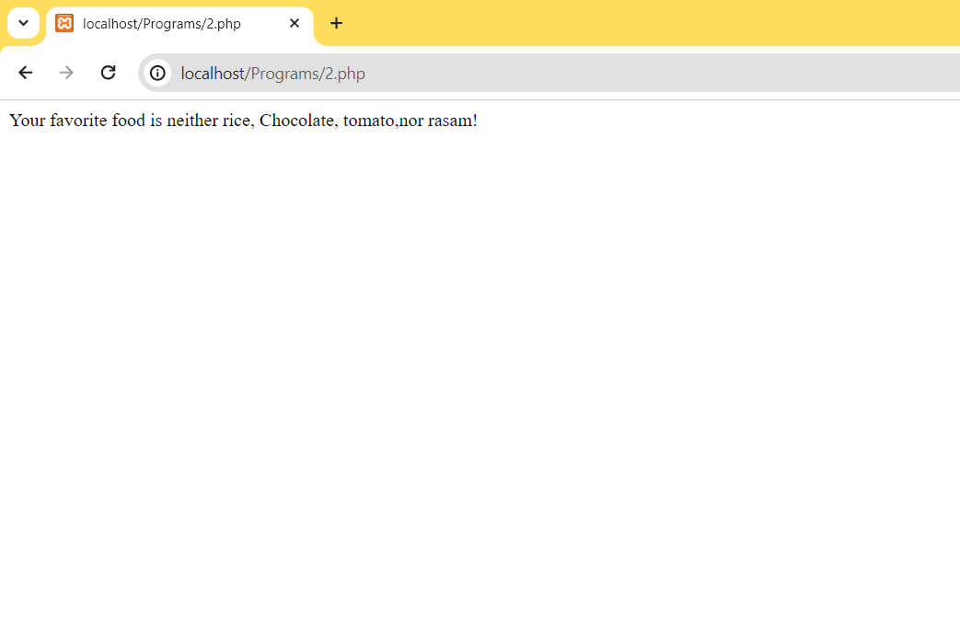

**RESULT:**

Hence, the ‘PHP’ program to implement the switch-case statement is executed and the output verified.

|  |  |
| --- | --- |
| **Ex.No : 3** | **FIBONACCI SERIES** |
| **Date: 29/01/2024** |

**AIM:**

To write a ‘PHP’ program to generate the Fibonacci series.

**ALGORITHM:**

1. Start
2. Assign the first two terms of the series with values 0 and 1 respectively.
3. Read the number of terms to be generated into a variable ‘n’.
4. Using a loop generate the next terms of the series, by adding the previous two termstill the value ‘n’.
5. Display the terms of the Fibonacci series.
6. Stop.

# PROGRAM:

<?php

$a=0;

$b=1;

echo "$a\n";

echo "$b\n";

for($x=2; $x<8;$x++)

{

$c=$a+$b;

$a=$b;

$b=$c;

echo "$c\n";

}

?>

# OUTPUT:

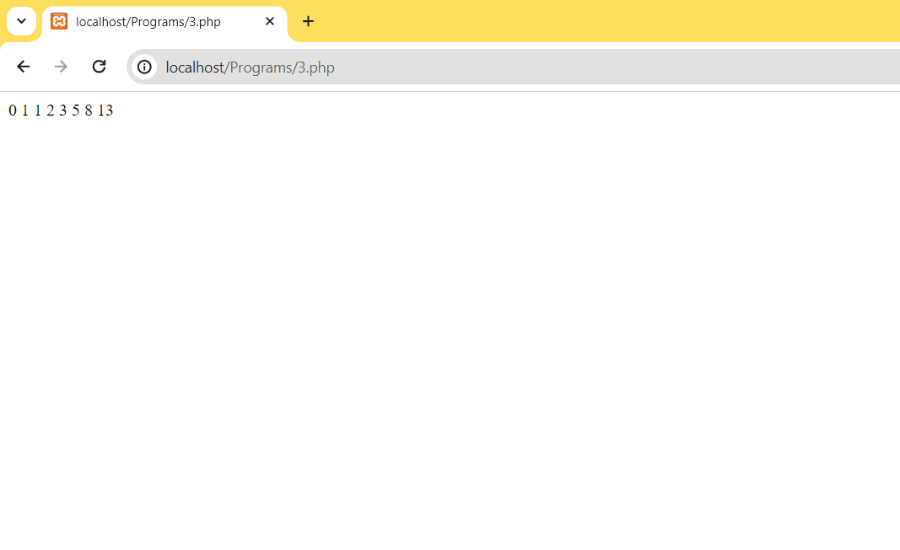

**RESULT:**

Hence, the ‘PHP’ program to generate the Fibonacci series is executed and the output verified.

|  |  |
| --- | --- |
| **Ex.No : 4** | **DETERMINE THE FACTORIAL OF A NUMBER** |
| **Date: 29/01/2024** |

# AIM:

To write a ‘PHP’ program to determine the factorial of a given number.

# ALGORITHM:

1. Start
2. Read the number from the user into a variable ‘num’.
3. Assign 1 to a variable ‘factorial’.
4. Using loop initialize variable ‘x’ to the number and till it is decremented to 1,multiply factorial with the value ‘x’.
5. Print the value of the variable ‘factorial’.
6. Stop.

# PROGRAM:

<?php

$num = 7;

$factorial = 1;

for ($x-$num; $x>=1; $x-)

{

$factorial = $factorial * $x;

}

echo 'Factorial of $num is $factorial";

?>

# OUTPUT:

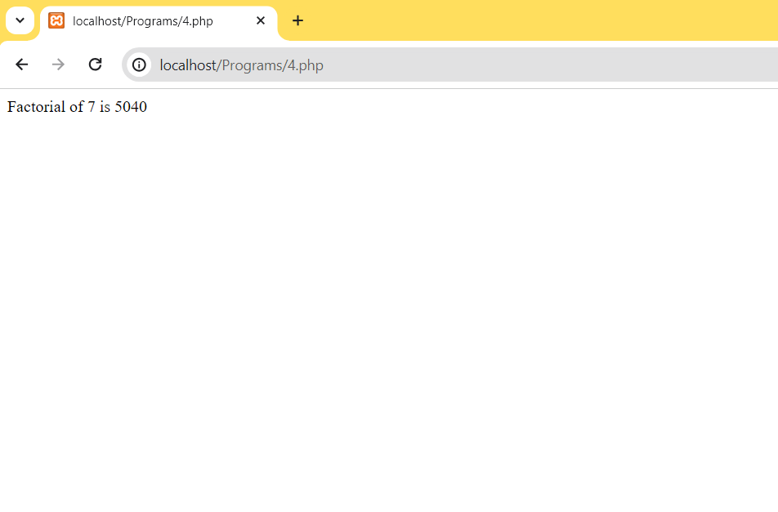

**RESULT:**

Hence, the ‘PHP’ program to determine the factorial of a given number is executed and the output verified.

|  |  |
| --- | --- |
| **Ex.No : 5** | **CLASS AND OBJECT** |
| **Date: 05/02/2024** |

# AIM:

To write a ‘PHP’ program to create class and object.

# ALGORITHM:

1. Start
2. Create a book class with properties author, title, pages.
3. Create an object for this class.
4. Assign the values for author, title, pages using the object.
5. Display the assigned values.
6. Stop.

# PROGRAM:

<?php

class Book

{

public $author;

public $title;

public $pages;

function set_name($name)

{

$this->name = $name;

}

function get_name()

{

return $this->name;

}

}

$author = new Book();

$title = new Book();

$pages = new Book();

$author->set_name('Author : Dr. APJ Abdul Kalam');

$title->set_name('Title : Wings of Fire');

$pages->set_name('pages : 180 pages');

echo $author->get_name() . "<br>";

echo $title->get_name() . "<br>";

echo $pages->get_name() . "<br>";

?>

# OUTPUT:

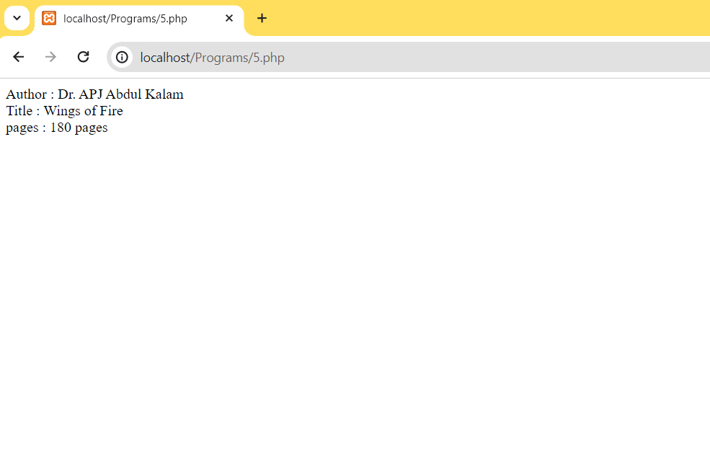

**RESULT:**

Hence, the ‘PHP’ program to create class and object is executed and the output verified.

|  |  |
| --- | --- |
| **Ex.No : 6** | **INHERITANCE** |
| **Date: 12/02/2024** |

# AIM:

To write a ‘PHP’ program to implement the concept of inheritance.

# ALGORITHM:

1. Start
2. Create a parent class with property and methods defined.
3. Create a child class which can access the properties and methods of the parent class.
4. Stop.

# PROGRAM:

<?php

class vehicle

{

public $name;

public $color;

public function __construct($name, $color)

{

$this->name = $name;

$this->color = $color;

}

public function intro()

{

echo "The car is (120) and the color is (red).";

}

}

class hyundai extends vehicle

{

public function message()

{

echo "which car is this?\n";

}

}

$hyundai = new hyundai("120", "red");

$hyundai->message();

$hyundai->intro();

?>

# OUTPUT:

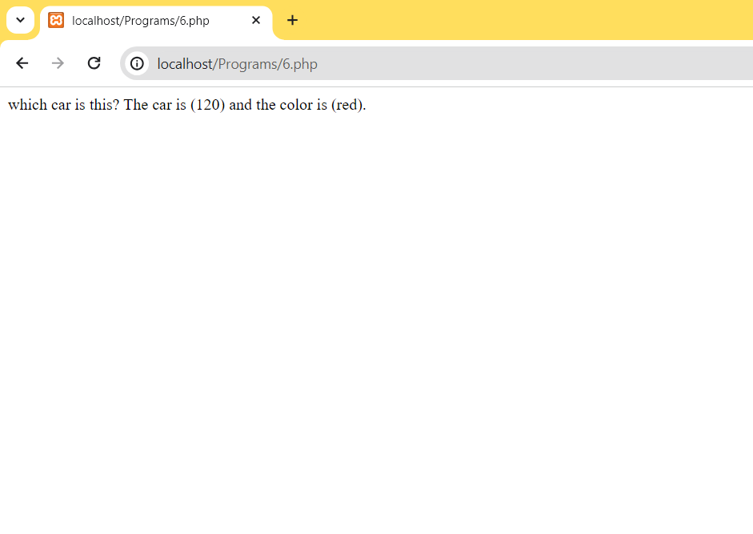

**RESULT:**

Hence, the ‘PHP’ program to implement the concept of inheritance is executed and the output verified.

|  |  |
| --- | --- |
| **Ex.No : 7** | **CONSTRUCTOR AND DESTRUCTOR** |
| **Date: 19/02/2024** |

# AIM:

To write a ‘PHP’ program to indicate the use of constructor and destructor methods.

# ALGORITHM:

1. Start
2. Create a class.
3. Define a construct method, user-defined method and destruct method within theclass.
4. Create an object for the class to access the user-defined method.
5. Stop.

# PROGRAM:

**CONSTRUCTOR**

<!DOCOTYPE html>

<html>

<body>

<?php

Class fruit

{

public $name;

public $color;

function __construct($name)

{

$this->name=$name;

}

function get_name()

{

return $this->name;

}

}

$apple=new fruit("apple");

echo $apple->get_name();

?>

</body>

</html>

# DESTRUTOR

<!DOCOTYPE html>

<html>

<body>

<?php

Class fruit

{

public $name;

public $color;

function __construct($name)

{

$this->name=$name;

}

function get_name()

{

return $this->name;

}

}

$apple=new fruit("apple");

echo $apple->get_name();

?>

</body>

</html>

# OUTPUT:

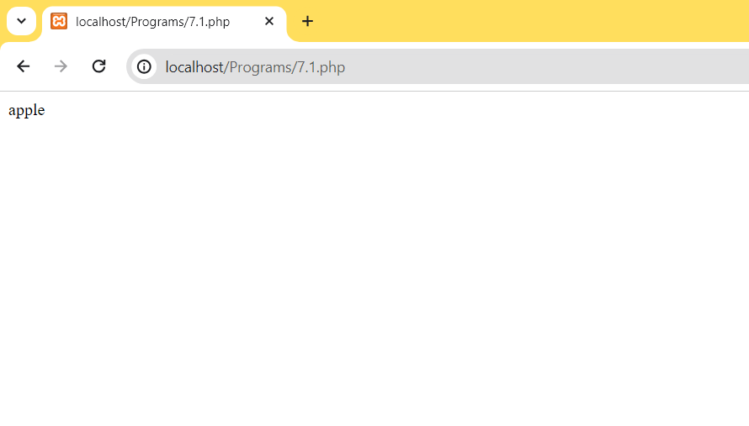

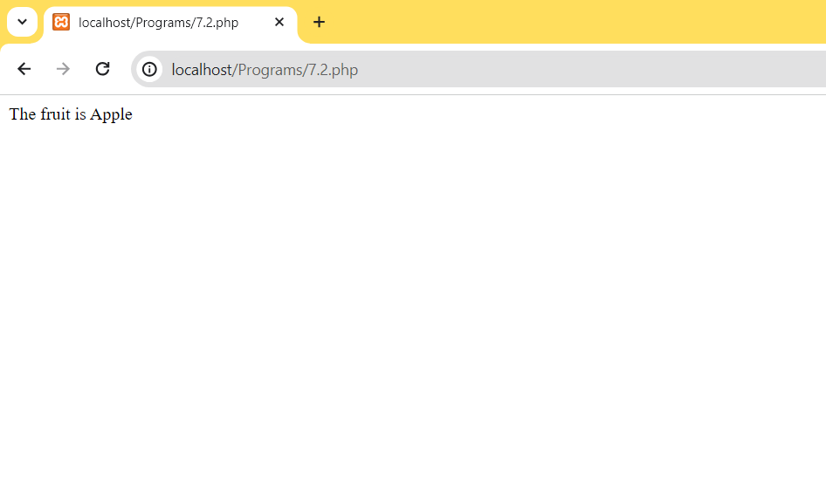

**RESULT:**

Hence, the ‘PHP’ program to indicate the use of constructor and destructor methods is executed and the output verified.

**Date: 02/03/2024**

**ROWS * COLUMNS MULTIPLICATION TABLE GENERATION**

**Ex.No : 8**

# AIM:

To write a ‘PHP’ program to generate the multiplication table of rows and columns using nested for loops.

# ALGORITHM:

* 1. Start
  2. Read the number of rows and the number of columns into ‘row’ and ‘col’ variable respectively.
  3. Use an outer for loop for the row and inner for loop for the column.
  4. Multiply the row and column values and display them column-wise.
  5. Repeat step (4) for the remaining rows.
  6. Stop.

# PROGRAM:

<!DOCTYPE html>

<html>

<head>

<style>

tr,td

{

border: 1px solid black;

padding:10px;

}

</style>

</head>

<body>

<?php

echo "My table";

echo "<table border='1' cellspacing='0'>";

for ($row=1;$row<=10; $row++)

{

echo "<tr>\n";

for($col=1;$col<=10;$col++)

{

$x=$col *$row;

echo "<td>$x</td>\n";

}

echo"</tr>";

}

echo"</table>";

?>

</body>

</html>

# OUTPUT:

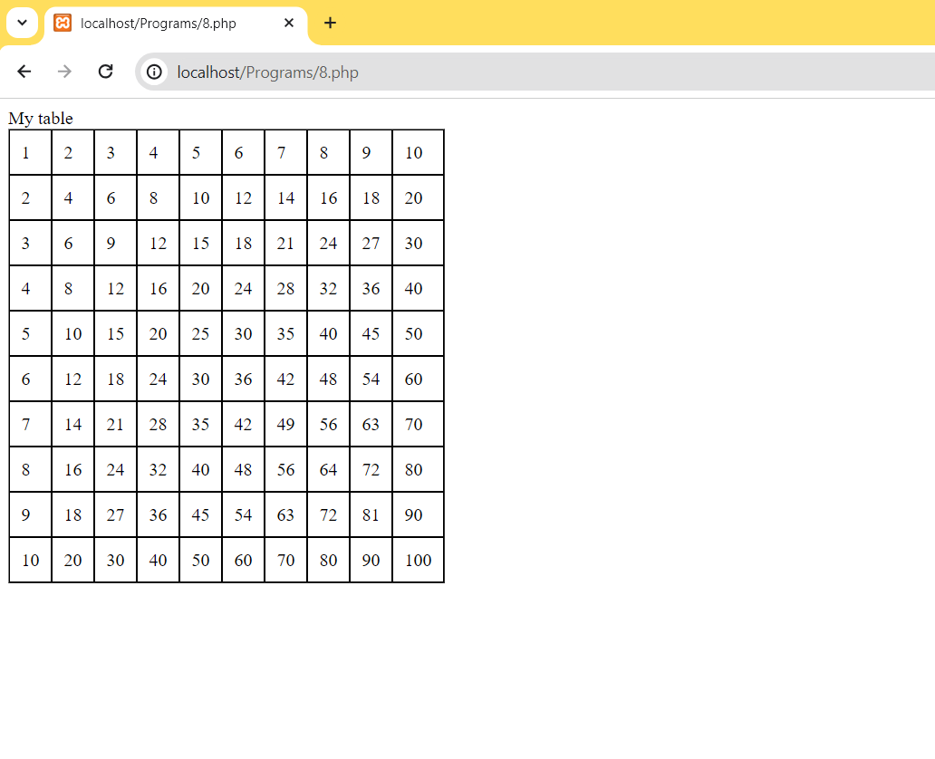

**RESULT:**

Hence, the ‘PHP’ program to generate the multiplication table of rows and columns using nested loops is executed and the output verified.

|  |  |
| --- | --- |
| **Ex.No : 9** | **SORTED ARRAY VALUES** |
| **Date: 02/03/2024** |

# AIM:

To write a ‘PHP’ program to create an array of different cities and display them in the sorted order as an unordered list.

# ALGORITHM:

1. Start
2. Initialize an array with names of different cities.
3. Display the values of the original array as an unordered list.
4. Apply the sort function to the original array.
5. Display the values of the sorted array as an unordered list.
6. Stop.

# PROGRAM:

<?php

$cities=array("Mumbai","Chennai","Hyderabad");

sort($cities);

$len=count($cities);

for($x=0;$x<$len;$x++)

{

echo $cities[$x]."\n";

}

?>

# OUTPUT:

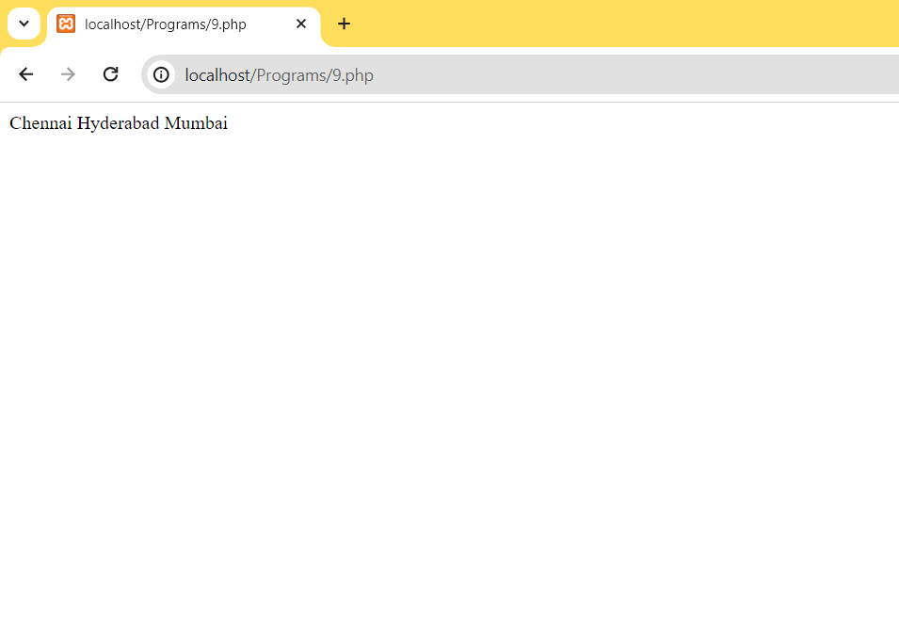

**RESULT:**

Hence, the ‘PHP’ program to create an array of different cities and display them in sorted order is executed and the output verified.

|  |  |
| --- | --- |
| **Ex.No : 10** | **STUDENT REGISTRATION FORM** |
| **Date: 04/03/2024** |

# AIM:

To write a ‘PHP’ program to design a student registration form and display the submitted details on to another page.

# ALGORITHM:

1. Start
2. Design a student registration form in register.php page.
3. Submit the registered details to success.php page and display them.
4. Stop.

# PROGRAM:

<html>

<body>

<form action="10 success.php" method="get">

Name: <input type="text" name="name"><br>

E-mail: <input type="text" name="email"><br>

Mobile Phn: <input type="text" name="Mobile-phn"><br>

<input type="submit">

</form>

</body>

</html>

**PHP**

<html>

<body>

Welcome <?php echo $_GET["name"];?><br>

Your email address is: <?php echo $_GET["email"];?><br>

Mobile number is:<?php echo $_GET["Mobile-phn"];?>

</body>

</html>

# OUTPUT:

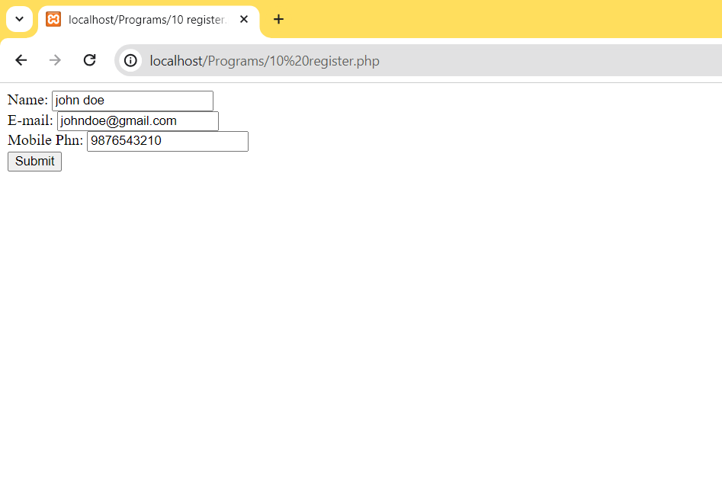

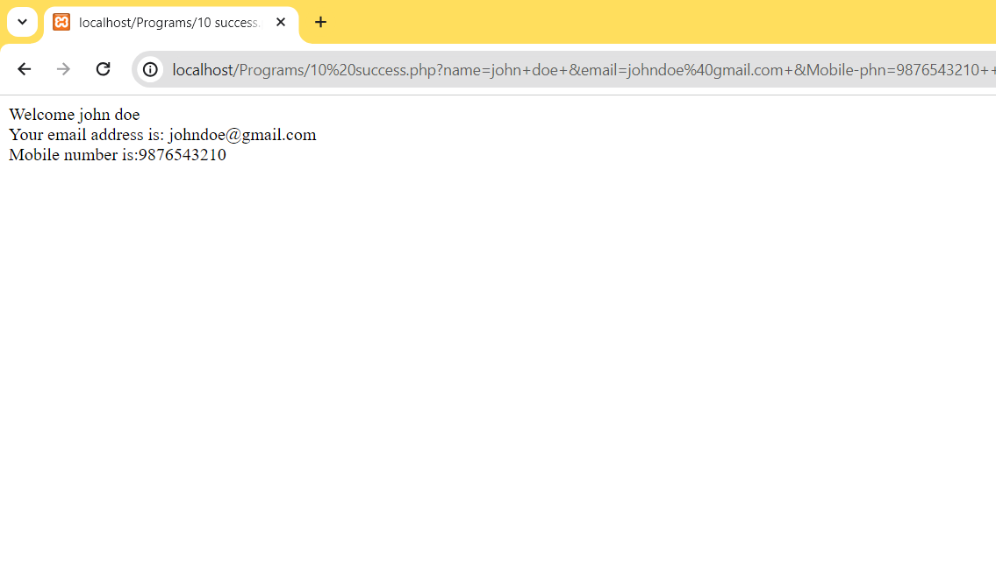

**RESULT:**

Hence, the ‘PHP’ program to design a student registration form and display the submitted details on to another page is executed and the output verified.

|  |  |
| --- | --- |
| **Ex.No : 11** | **INSERTING RECORD INTO A TABLE USING PHP/MySQL** |
| **Date: 11/03/2024** |

# AIM:

To write a ‘PHP/MySQL’ program to insert a record into a database table.

# ALGORITHM:

1. Start
2. Assign server name, user name, password, dbname , conn varaiables with therequired values.
3. Check if the connection was successful. If not, print connection failed, else, proceedto step (4).
4. Insert a record and assign that SQL query to sql object.
5. Check the execution of the query with the conn object. If successful, print “recordinserted successfully” else print “error”.
6. Close the connection.
7. Stop.

# PROGRAM:

**insert.php:**

<html>

<style>

form,input

{

padding:10px;

margin:10px;

}

</style>

<body>

<title>Insert Data</title>

<form action="Main.php" method="POST">

<input type="text" name="Name" placeholder="Name"><br>

<input type="email" name="Email" placeholder="Email Id"><br>

<input type="mobile" name="Mobile" placeholder="Mobile-number"><br>

<input type="text" name="Department" placeholder="Department"><br>

<input type="submit" name="submit">

</form>

</body>

</html>

**Main.php:**

<?php

$con = mysqli_connect('localhost','root','');

if(!$con)

{

echo "Not Connected to server";

}

if (!mysqli_select_db($con,'computer'))

{

echo "Database is not selected";

}

$Name = $_POST['Name'];

$Email = $_POST['Email'];

$Mobile = $_POST['Mobile'];

$Department = $_POST['Department'];

$sql="INSERT INTO details (Name,Email,Mobile,Department) VALUES

('$Name','$Email','$Mobile','$Department')";

if (!mysqli_query($con,$sql))

{

echo "Failed";

}

else

{

echo "Passed";

}

header("refresh:2; url=insert.php");

?>

# OUTPUT :

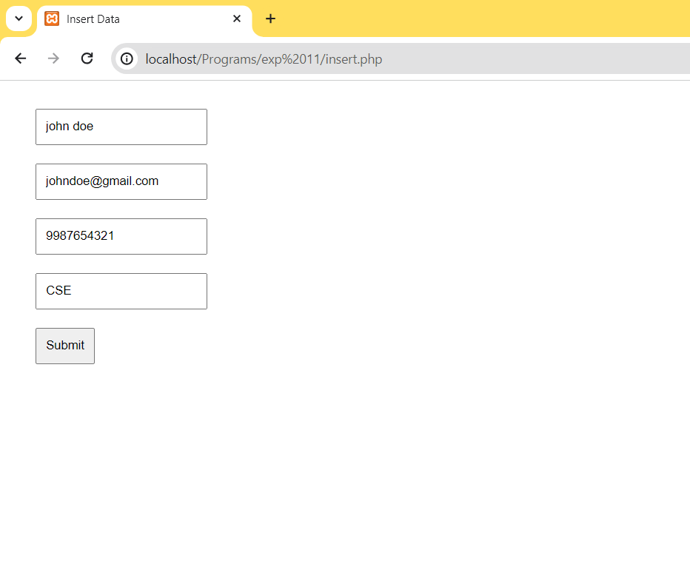

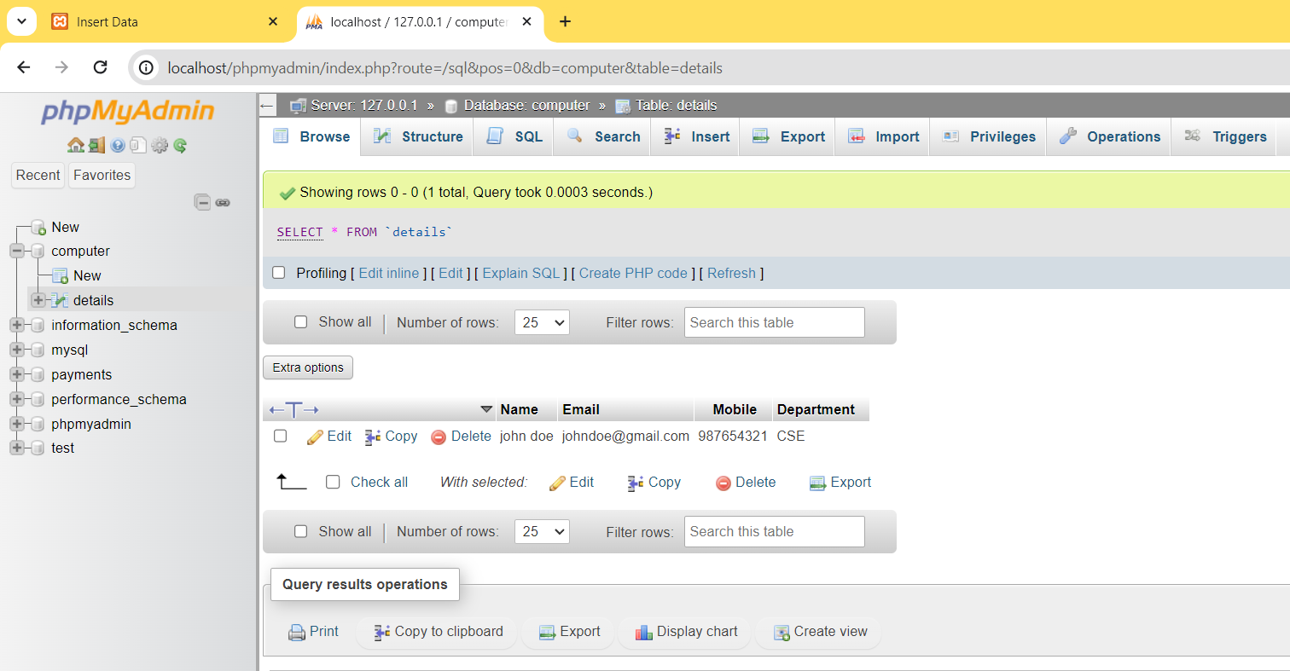

**RESULT:**

Hence, the ‘PHP/MySQL’ program to insert a record into a database table is executed and the output verified.

|  |  |
| --- | --- |
| **Ex.No : 12** | **TRACKING THE NUMBER OF VISITS MADE TO A PAGE** |
| **Date: 18/03/2024** |

# AIM:

To write a ‘PHP’ program to track the number of visits made to a page.

# ALGORITHM:

1. Start
2. Initialize the session.
3. If the session isset is true, increment the counter value by 1, otherwise, do not alterthe initial counter value which was 1.
4. Print the number of times the page was visited.
5. Stop.

# PROGRAM:

<?php

session_start();

if(isset($_SESSION['views']))

$_SESSION['views'] = $_SESSION['views']+1;

else

$_SESSION['views']=1;

echo"Total number of views : ".$_SESSION['views'];

?>

# OUTPUT:

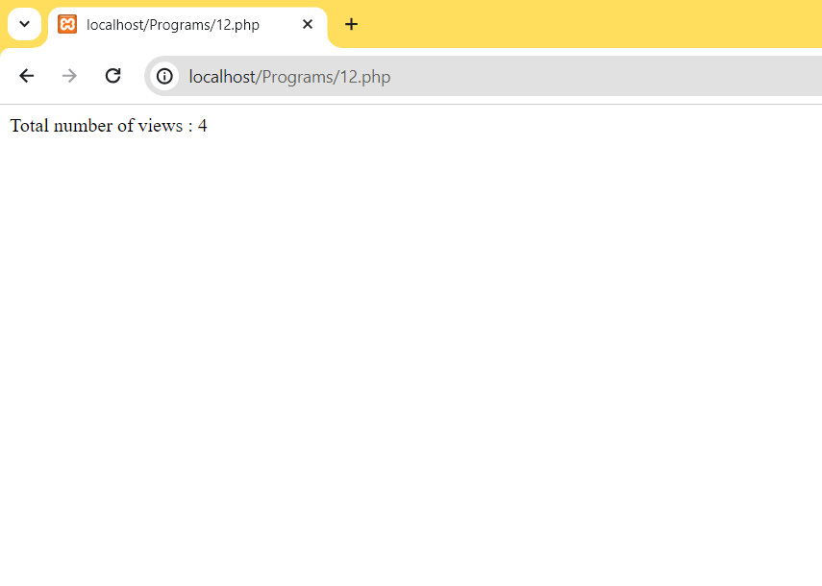

**RESULT:**

Hence, the ‘PHP’ program to track the number of visits made to a page is executed and the output verified.